Exercise 1:
void main() {
String zone = "ABC"; // Change to XYZ, ABC, or PQR
double weight = 12.5; // Weight in kg

double costPerKg;

if (zone == 'XYZ') {
costPerKg = 5;
} else if (zone == 'ABC') {
costPerKg = 7;
} else if (zone == 'PQR') {
costPerKg = 10;
} else {
print("Error: Invalid destination zone!");
return;
}

double totalCost = costPerKg * weight;
print("Destination Zone: $zone");
print("Weight: $weight kg");
print("Total shipping cost: \$${totalCost.toStringAsFixed(2)}");
}

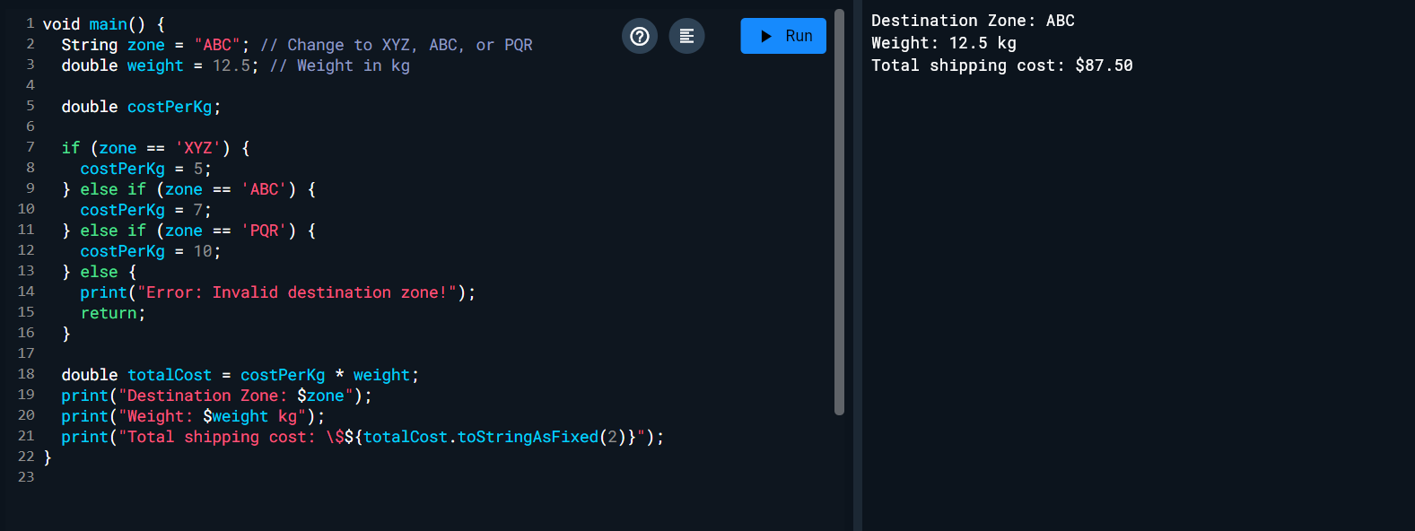
Exercise 2:
void main() {
double bill = 1200; // total bill amount
int people = 4; // number of people

if (people <= 0) {
print("Error: Number of people must be greater than 0");
return;
}

double splitAmount = bill / people;
print("Each person should pay: \$${splitAmount.toStringAsFixed(2)}");
}
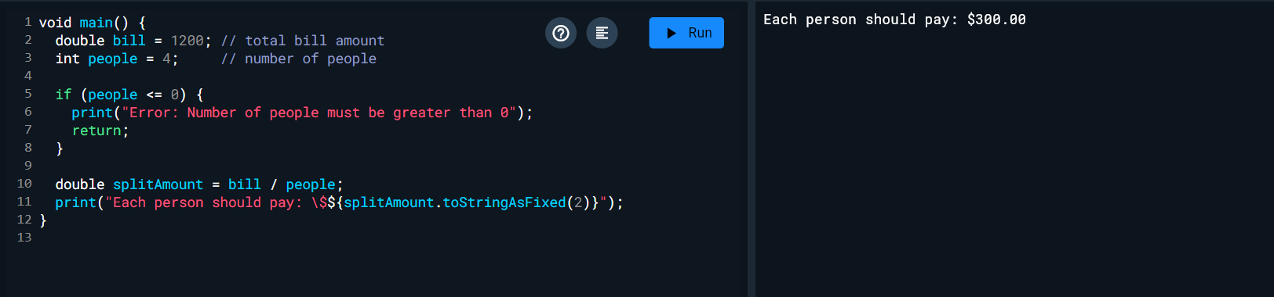
Exercise 3:

void main() {
List<int> a = [1, 1, 2, 3, 5, 8, 13, 21, 34, 55, 89];

print("Numbers less than 5:");
for (int num in a) {
if (num < 5) {
print(num);
}
}
}
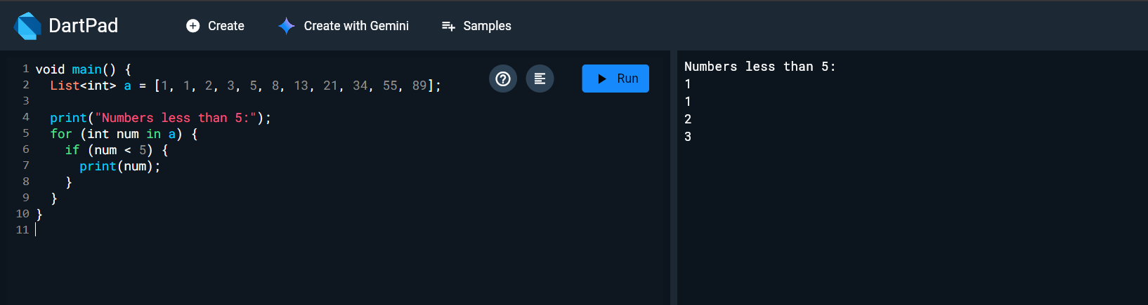
Exercise 4:
void main() {
String input = "3, 5, 7, 23"; // Replace with your numbers

List<String> numList = input.split(',').map((e) => e.trim()).toList();
Set<String> numSet = numList.toSet();

print("List: $numList");
print("Set: $numSet");
}

